Creating Custom Color Palettes in Tableau

1. Find your *preferences.tps* file using windows explorer or finder
2. Open *preferences.tps* using a text editor like notepad, it will look like:

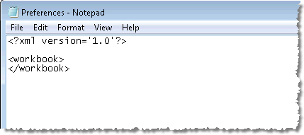

1. Between “<workbook> and </workbook> , copy and paste the following script, and save the file.

<preferences>

<color-palette name="MTS Receipts - Emerald to Lime" type="regular">

<color>#1E3B22</color>

<color>#274729</color>

<color>#305430</color>

<color>#3B6137</color>

<color>#466F3D</color>

<color>#517C44</color>

<color>#5E8A4A</color>

<color>#6B9850</color>

<color>78A656</color>

<color>#87B45C</color>

<color>#96C261</color>

<color>#A6D167</color>

<color>#B6DF6C</color>

<color>#C7EE71</color>

<color>#D9FC77</color>

</color-palette>

<color-palette name="MTS Outlays - Teal to Turquoise" type="regular">

<color>#07272A</color>

<color>#0F393D</color>

<color>#174B51</color>

<color>#205E66</color>

<color>#2A717D</color>

<color>#358594</color>

<color>#409AAC</color>

<color>#4DAFC5</color>

<color>#5AC4DF</color>

<color>#69DAF9</color>

</color-palette>

<color-palette name="MTS Fig 1" type="regular">

<color>#8cb95e</color>

<color>#174b51</color>

<color>#f7d500</color>

</color-palette>

<color-palette name="White" type="regular">

<color>#ffffff</color>

</color-palette>

                </preferences>

1. When you restart Tableau, you should see the color palettes when you need to edit colors.

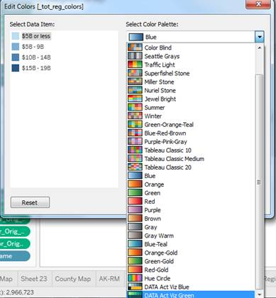

Let me know if you have any questions or issues getting this set up!